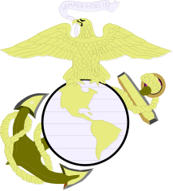

UNITED STATES MARINE CORPS

Professional Resume

For

Sergeant Major Eric E. Cayson

t

Director
Senior Enlisted Academy
Ed Cmd, TECOM
MCB Quantico

3078 Upshur Ave
Quantico, VA 22134
Comm. (703)432-4793
Email: eric.cayson@usmc.mil
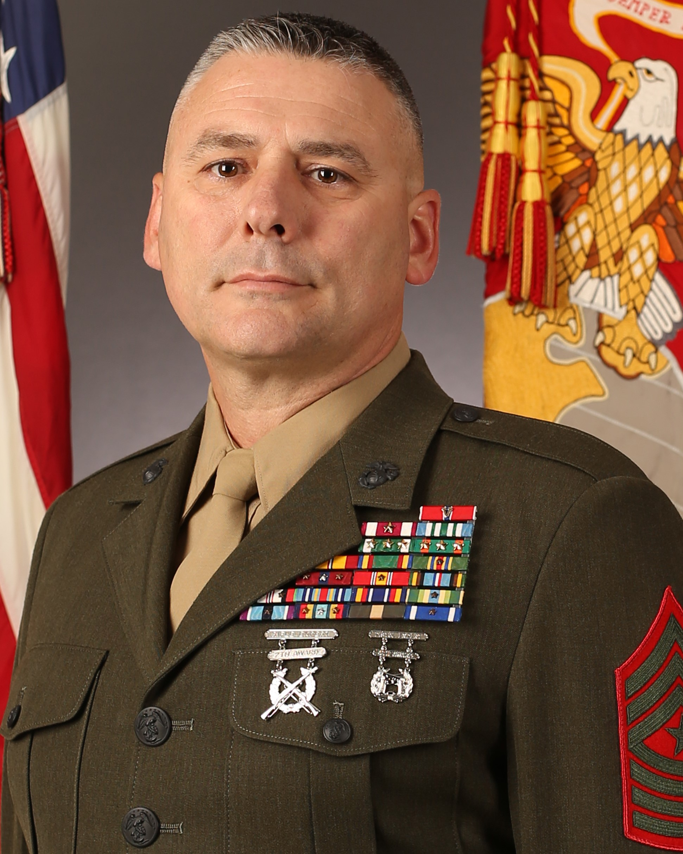

MAJOR AWARDS & DECORATIONS
Bronze Star Medal w/ Combat Distinguishing Device
Meritorious Service Medal w/ one gold star
Joint Commendation Medal
Navy and Marine Corps Commendation Medal
w/ three gold stars
Combat Action Ribbon

COMBAT TOURS
2010 OEF
2011 OEF

Personal Information
Date of Rank: 1 September 2015
Spouse’s Name: Heather
Children: Ryan, Bradley
POB/Date: Winter Haven, FL / 22 July 1976

EDUCATION (Civilian & Military)

Date School / Degree

1994 Bartow High School / High School Diploma
2002 Campbell University / Associates Degree
2003 Drill Instructor School
2006 Warfighting
2009 Senior Enlisted Joint PME (Non-Res)
2013 Naval War College Senior Enlisted PME (Non-Res)
2013 U.S. Navy Senior Enlisted Academy
2014 U.S. Air Force Senior NCO Academy
2015 USMC Cornerstone Course
2019 Bachelor’s Degree Human Resource Management

CHRONOLOGY OF ASSIGNMENTS
Inclusive Dates Unit Position
1810 – Pres Sr Enlisted Academy Director
1704 - 1809 CLB-26 SgtMaj
1506 - 1704 HMLA-167 SgtMaj
1208 - 1506 Co I, 3d Bn, 23d Mar I-I 1stSgt
1001 - 1208 2d Bn, 6th Mar Co 1stSgt
0612 - 1001 HMH-464 Airframes Division Chief
0307 - 0612 MCRD Parris Island DI, SDI, Ser GySgt, Co GySgt
9904 - 0307 HMT-302 CH-53 Airframes Instructor
9506 - 9904 HMH-461 CH-53 Airframes Mechanic
9502 - 9506 HMT-302 CH-53 Airframes Student
9411 - 9502 NATTC Millington, TN Airframes Student
9410 - 9411 MCT Bn, SOI East MCT Student
9407 - 9410 MCRD Parris Island Recruit

