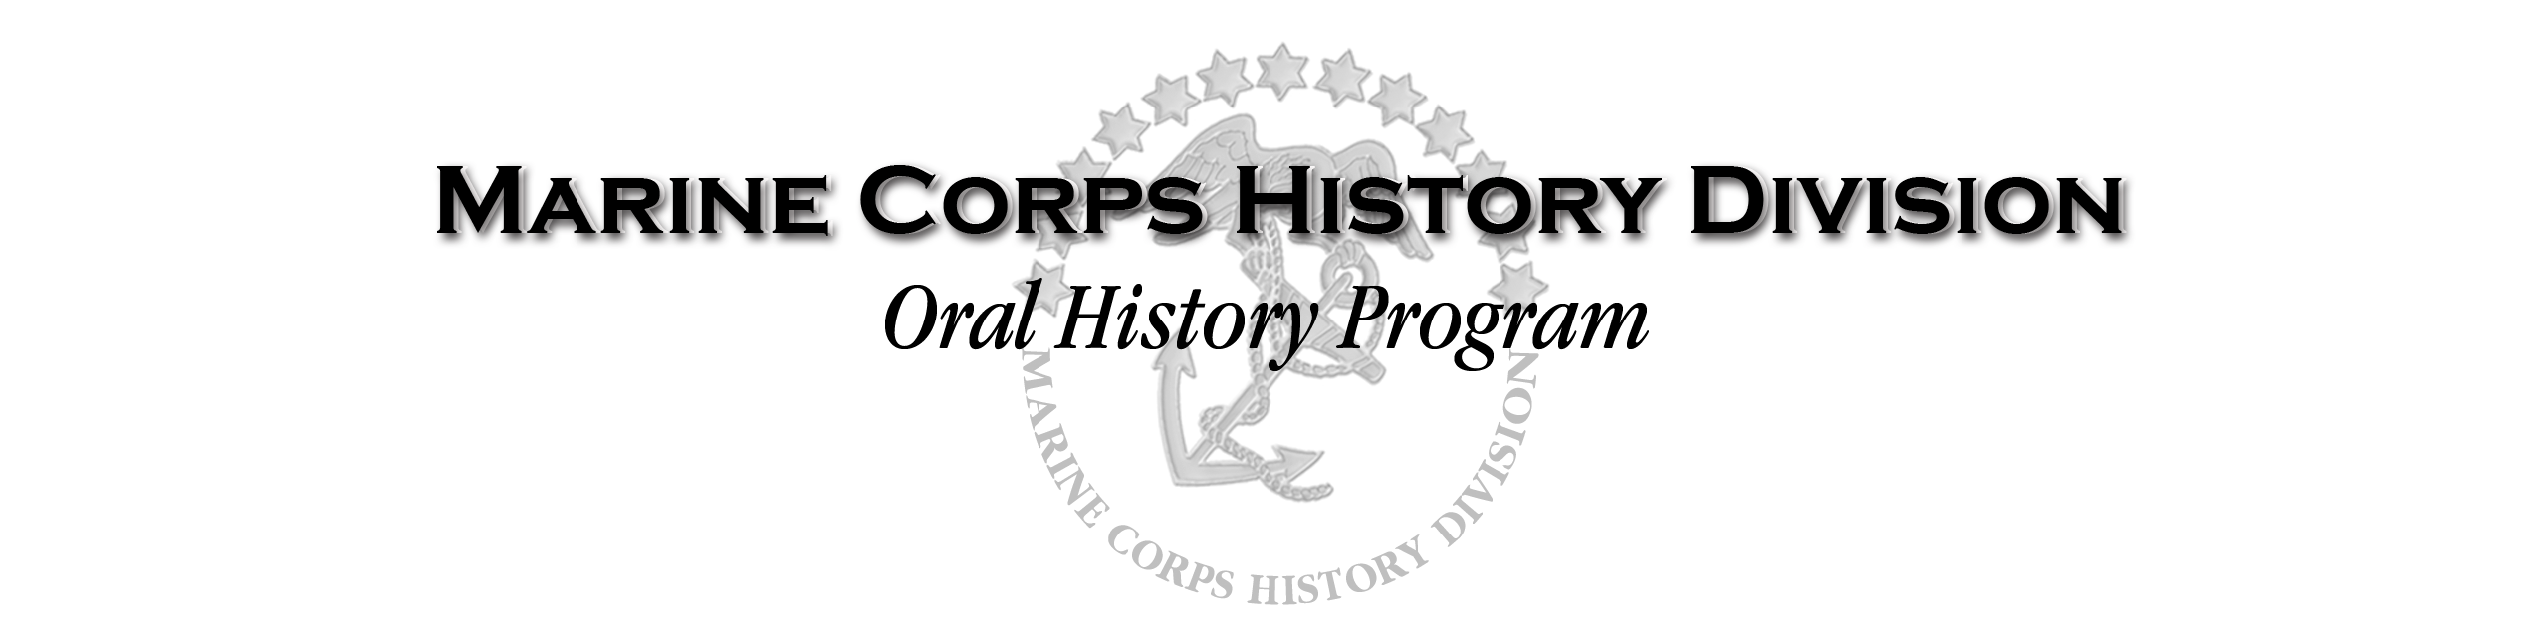

RELEASE

As a participant in the Marine Corps’ Oral History Program (MCOHP), I/we, _________________________ (and) _____________________, understand that the purpose of the MCOHP is to collect audio- and video-taped oral histories, and selected related documentary materials (such as photographs, manuscripts, journals and diaries) of individuals whose experiences are pertinent to Marine Corps history. The materials will serve as a record of the Marine Corps’ history and they may be used for exhibition and publication, including presentation on the World Wide Web and successor technologies, as well as for promotion of the Marine Corps and its activities in any medium.

I/we grant to the Marine Corps sole ownership of the physical property delivered to historical agencies of the Marine Corps, and the right to use any property that is the outcome of my participation; for example, my recorded interview, any photographs, and any written materials, such as letters, diaries, and accounts I may provide MCOHP. By granting this permission, I/we understand that I/we do not give up any copyright or performance rights that I/we may hold.

I/we also grant to the Marine Corps my absolute and irrevocable consent for any photograph(s) provided by me or taken of me in the course of my participation in the MCOHP to be used, published, and copied by the Marine Corps and its assignees, in any medium.

Finally, I/we agree that the Marine Corps may use my name, my video or photographic likeness, my statements, and voice reproduction without further approval being required of me.

I/we release the Marine Corps, and its assignees and designees, from any and all claims and demands arising out of, or in connection with, the use of such recordings, documents, and artifacts, including but not limited to, any claims for defamation, invasion of privacy, or right of publicity.

ACCEPTED AND AGREED

Signature of Interviewee (and Interviewer – if not a federal employee)

_________________________________________ _________________________ Date _____________

Printed name(s) ______________________________ ______________________________

Address(es)____________________________________________________________

Telephone ( ) _____________ - _____________ and/or email: _____________________________

