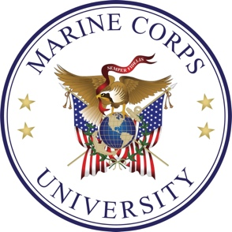

Marine Corps Civilian Leadership Certificate Program Plan

Program Overview:

The Civilian Leadership Certificate Program offers participants the opportunity to develop and strengthen their leadership skills and competencies. This comprehensive program combines online learning with in-person leadership seminars conducted through the Lejeune Leadership Institute. Upon successful completion of all program requirements, participants will be awarded a Certificate in Leadership from Marine Corps University.

Program Requirements:

Marinenet course - LLICLCP001

Lead Self Seminar

Lead Teams Seminar

Lead People Seminar

Participants may complete the program requirements in any sequence, as no prerequisites are required. Upon completion of all requirements, participants must submit documentation of completion to the Lejeune Leadership Institute for verification and issuance of the Leadership Certificate.

