Choice Theory Basics by Dr. William Glasser

What is Choice Theory? Developed by psychiatrist [William Glasser](http://wglasser.com/index.php), Choice Theory states humans are motivated by a never-ending quest to satisfy 5 basic needs woven into our genes: to love and belong, to be powerful, to be free, to have fun and to survive. Specifically: Survival, belonging, power, freedom, and fun. He digs deeper into these human needs by examining the effects of them on our behaviors which leads to his concept of “Total behavior--The behavioral system”.

One of Dr. Glasser's major premises is that "All behavior is purposeful". That is, all our behavior is our best attempt at the time, given the resources at our disposal (knowledge, skills, etc.) to meet our needs. Another way of putting it is all our behavior is an attempt at making the real world conform to the pictures in our quality world.   
Most of the time we choose behaviors that Glasser terms *organized behaviors*.

Used behaviors are ones that we are familiar with, that we have used before. For example, when I want to meet my need for fun, one of my organized behaviors is to go out to dinner with my partner and another couple. That is a behavior that has

worked firmly in the past.

If we do not have an organized behavior immediately available, or organize

behaviors that have worked in the past are not working in the current situation, we

can figure out new behaviors. Glasser terms this process *reorganizing*; this is our

creativity, which is always going on, whether we decide to use it or not.

Total Behavior

According to Dr. Glasser all behavior is total behavior, made up of four components:

1. Acting
2. Thinking
3. Feeling
4. Physiology

All four components are present all the time, and we name our current behavior by the most obvious component. Like the wheels of a car, if one-wheel changes direction or speed, the others follow.

For example, if I am jogging, the most obvious component is the **acting** component. But while I am jogging, I may be **thinking** a number of things: "What a beautiful day!" or, "I love these new running shoes," or "I wonder if I can make it up this hill." I am also **feeling** something: exhilaration, possibly, or gladness, or maybe even a little fear at times. Simultaneously, my **physiology** is pumped up. My heart rate is up, my muscles are working, and I'm sweating. This would be in my total jogging behavior. All four components are present, but we named the behavior after the most salient component, acting.

In contrast, a behavior named after the **feeling** component might be being angry. But while I am angry, I may be **thinking**, "How dare this person treat me this way!" I may be *doing* something like yelling or pacing. And my **physiology** would most likely include muscle tension and shallow breathing, among other things.

A behavior named after the *thinking* component is meditating. While I am meditating, my *acting* behavior would probably be sitting. My *feeling* component would be contentment, and my *physiology* would be slowed down.

Finally, a behavior named after the physiological component is shivering. While I am shivering, I might be feeling frustrated. I might be thinking, "Why didn't I'd wear a coat?" and I might be doing anything I could think of to get warmer, running in place, cuddling up to my partner, etc.

All four of these components are occurring all the time, and when we change one of the components, the other three changes accordingly.

What Can We Control?

According to Glasser, we choose all our behaviors. The component we have the most control over is our acting. The next most easily controlled component is our thinking. Therefore, if we want to change the way we are feeling emotionally or physically, the most effective thing to do is to change what we are doing. If, because of the situation, we can't change what we are doing, we can change what we are thinking.

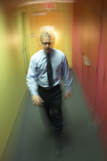For example, if I have experienced frustration most of the day, I may be feeling angry, my body may be tense, I may be thinking "I hate my job!" and I may be complaining about it to a co-worker. The acting component of my behavior, complaining, may not be helping me feel better physically or emotionally. So, if I changed that component and, say, take a brisk walk, I will most likely change what I'm thinking, which will in turn help me feel better both emotionally and physically

Putting it together

This diagram attempts to pull together the five sections of choice theory. On the left are the 5 basic human needs. The real world is on the right. However, what is perceived is only that information that has successfully passed through the knowledge and values filters. What is perceived is compared to the images stored in the individual's quality world. Behavioral choices are made as a result. Total behavior includes acting, thinking, feeling and physiology. Some of these components of total behavior are easier to change than others.

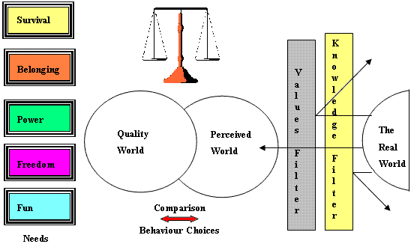

Extracted 12/8/2017: (https://lo.unisa.edu.au/mod/book/view.php?id=454028&chapterid=74015)