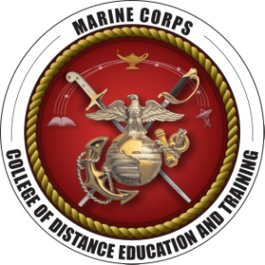**United States Marine Corps  
College of Distance Education and Training  
CSCDEP and EWSDEP International Blended Seminar Program**

Student Enrollment Request Form

(Diploma printed using this information)

Last Name: ..... First Name: .....

Rank/Pay Grade: ..... Branch of Service: Select

MarineNet/Blackboard Username: ..... Requested Program: Select

Phone Numbers:

Work: ..... DSN: ..... Home: ..... Cell: .....

Email:

Preferred: ..... Secondary: .....

Work/Official Mailing Address:

|  |  |  |
| --- | --- | --- |
| Street | | |
| Street | | |
| City | State | Zip Code |
| City | State | Zip Code |

Home/Secondary Mailing Address:

|  |  |  |
| --- | --- | --- |
| Street | | |
| Street | | |
| City | State | Zip Code |
| City | State | Zip Code |

|  |
| --- |
| Comments (for official use only):  ..... |

|  |
| --- |
| Local Billeting Information: .....  Type comments in text box: ..... |

Submit CSCDEP International Blended Seminar requests to the CSCDEP IMSO, Mr. Dennis Haskin ([dennis.haskin@usmc.mil](mailto:dennis.haskin@usmc.mil)). Submit EWSDEP International Blended Seminar requests to the EWSDEP IMSO, Mr. Stuart Weinstein ([stuart.weinstein@usmc.mil](mailto:stuart.weinstein@usmc.mil)).