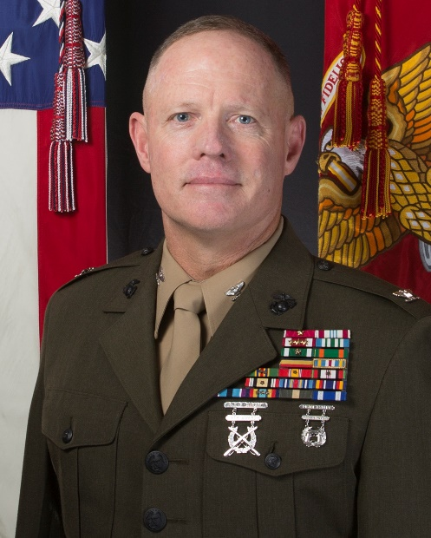
Colonel Thomas J. Gordon, USMC

Colonel Gordon was born in Boston, Massachusetts. After graduating from The Citadel in 1991, he was commissioned a Lieutenant in the United States Marine Corps. Completing training in 1992, he served with 1st Tank Battalion, 1st Marine Division until 1995 when he received orders to Marine Corps Recruit Depot (MCRD), Parris Island where he served as Echo Company Commander, 2nd Recruit Training Battalion.

Following completion of the Armor Officers Advance Course in 1998, Captain Gordon served as the Company Commander of Bravo and Alpha Companies, as well as the Battalion’s Assistant Operations Officer with 2nd Tank Battalion, 2nd Marine Division. In 2000 he was assigned to 8th Tank Battalion where he served as the Inspector Instructor in Syracuse, New York. After mobilizing the unit, he was assigned to I Marine Expeditionary Force (MEF) G-3 for Operation IRAQI FREEDOM.

After returning from Iraq in 2003, Major Gordon was transferred to USCENTCOM J-3 where he served as an Action Officer and a Plans Branch Chief. During his tour he served in Afghanistan, Iraq, Kuwait, and Qatar coordinating the force rotations and coalition support.

Transferred to Okinawa in the summer of 2006, Lieutenant Colonel Gordon was assigned to the III MEF G-3 where he served as the Current Operations Officer and Operations Officer for 3d Marine Expeditionary Brigade (MEB). As the 3d MEB G-3 for SEA ANGEL II, he coordinated disaster relief operations in the People's Republic of Bangladesh.

In June 2008, Lieutenant Colonel Gordon assumed command of 1st Tank Battalion, 1st Marine Division, Twenty-nine Palms, California. During his command tour, he stood up 3d CEB as the Acting CO. In 2010, the Battalion formed the core of a Special Purpose Marine Air Ground Task Force (SPMAGFT) in support of the European Commander’s theater security objectives. As the Commander of the first Black Sea Rotational Force, he led targeted security cooperation activities with ten partner nations in the Caucasus, Balkans, and Black Sea regions.

Relinquishing command in the summer of 2010, Lieutenant Colonel Gordon completed his senior level education tour as the Commandant’s Fellow at the Massachusetts Institute of Technology (MIT) for Academic Year 2010-11.

In June 2011 Colonel Gordon deployed with the MEF (Forward) as the Lead Planner and Liaison Officer for the drawdown in Afghanistan. In 2012 Colonel Gordon assumed the duties as the Marine Forces Central Command Assistant Chief of Staff for Operations, G-3.

In 2014, Colonel Gordon assumed Command of II MEF Headquarters Group (MHG). Under his command, the Groups’ 4,000 Marines and Sailors executed combat operations and provided world-wide communications, intelligence, electronic and cyber warfare capabilities, force protection, and supporting arms integration and liaison capabilities support for all Marine Expeditionary Forces deploying from the East Coast

In 2016, Colonel Gordon was nominated and selected to represent the Marine Corps, as a Military Fellow at the Council on Foreign Relations in New York City.

From 2017 to 2019, Colonel Gordon served the Military Secretary to the 37th Commandant of the Marine Corps. As the Chief of Staff and executive assistant to the Service Chief, he coordinated staff action to ensure the effective integration and alignment of policy, plans, and decisions governing the manning, training, and resourcing of the Corps’ 200,000 Marines, 13,000 civilian employees, and an annual operating budget of $42 billion.

In July 2019, Colonel Gordon assumed his current duties as the Director of the Marine Corps’ Command and Staff College. In June 2021 he will transition from the active ranks after thirty years of faithful service.

