Ali’i Battalion Leadership Philosophy
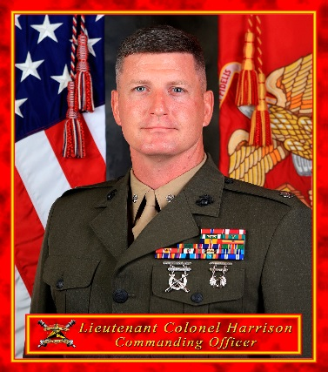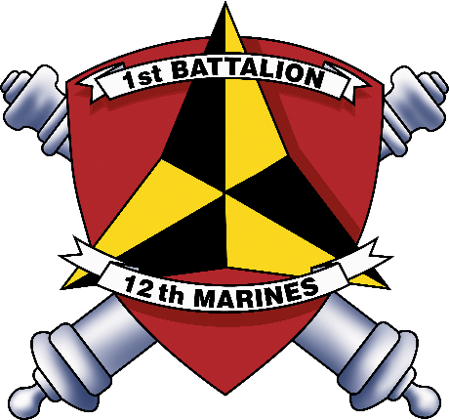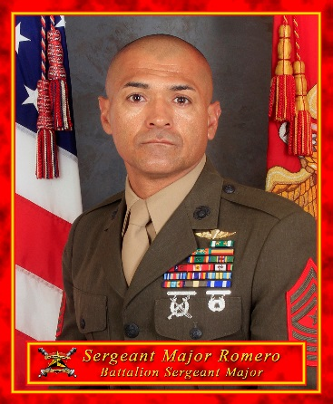
We exist solely to serve our Nation. We must be most ready when America is least ready. This means we must be ready to “Fight Tonight” with what we can carry on our backs, in the holds of an amphibious ship or aircraft, or with what we can draw from Maritime Pre-positioned Ships. Our task and purpose is to fight and win as part of the CALTRAP Division. Our leaders are strong, smart, adaptive, determined, and resilient.

We are Warrior-Citizens. Our warriors fight for and with the trust and confidence of our Nation. We protect both the idea and letter of the Constitution of the United States of America. In doing so, we protect the interests of our family, friends, and fellow citizens. Our leaders are honorable, self-sacrificing servants to our Nation and those they serve beside. We lead with Honor, Courage, and Commitment. Our leaders develop responsible citizenship traits in our Marines and Sailors.

We are Professionals. As professionals, we take our business seriously and experience joy in doing it well. We don’t take things personally. We are proficient and balanced in our occupational specialties and roles. We are disciplined in our personal conduct. Every Marine and Sailor has value. We recognize the individual’s unique contribution to the whole. We are trustworthy, loyal, and accountable to one another and those we serve. We build depth in our unit while training our replacement in the line. Our best examples lead from the front. We close ranks on those in need until they can carry their own load and resume their place in the line. Our Leaders are approachable, caring, and compassionate. Our Leaders foster esprit-de-corps, raising the next generation of Marines and Sailors to take our place, while guaranteeing mission success today.

We are Combat Ready. Our legacy as Marines demands that we be the “First to Fight”. In the Pacific, this requires that we forward deploy on short notice to intervene across a range of contingencies and crises. Our focus remains on high-intensity combat. Our Marines and Sailors must take an individual interest in being ready to deploy in every facet of their lives. Our people, equipment and families must be maintained at the highest level possible. Our leaders train, equip and fight to be the most combat ready artillery battalion in the Marine Corps.

Our enemies fear us because of our NCOs, SNCOs, and officers. They fear us because a well led battalion will succeed against all odds. Lead your Marines and Sailors well. Demand the same of your leadership.

B. B. HARRISON J. L. ROMERO

