Step 1: Complete Cyber Awareness/PII Training (CYBERM0000)
All DoD personnel (military, civilian, and contractors) must complete the annual Cyber Awareness/PII training (CYBERM0000) before requesting an EDU account. If you already have an up-to-date certificate skip to step 2.
Go to MarineNet: https://www.mcele.usmc.mil/marinenet/ssologin.aspx?ReturnUrl=/id3/api/redirect?app=aem
For more instructions on creating a MarineNet account go to:
https://portal.mcele.usmc.mil/content/mnet-portal/en/help/help-topics/login.html#hc-b2c0627660370eec(Copy and paste into your browser.)

- Click LOGIN (top right).
- Log in or create a MarineNet account by following the prompts, either by:
• Using your CAC to sign in, or
• Manually entering your information to create an account.
- Lookup Cyber Awareness Training (CYBERM0000) and enroll in training.
Note: The are two trainings to complete in order to acquire certificate.
• Department of the Navy Annual Privacy Training (DONPII010A)
• DOD Cyber Awareness Challenge (DODCAC1000)
- Complete the USMC Cyber Awareness Training (CYBERM0000).
- Save your CYBERM0000 certificate when finished. You will need it for your EDU account request.
If you have trouble with MarineNet: Use the MCeLE Help and Frequently Asked Questions (FAQs) links at the bottom of the MCeLE page.

Step 2: Create Your EDU Account Using AutoSAAR
AutoSAAR is CAC-enabled. Ensure your CAC is inserted before starting.
- Create an AutoSAAR user account https://autosaar.usmc.mil/ (Copy and paste into your browser). Click on the accept button
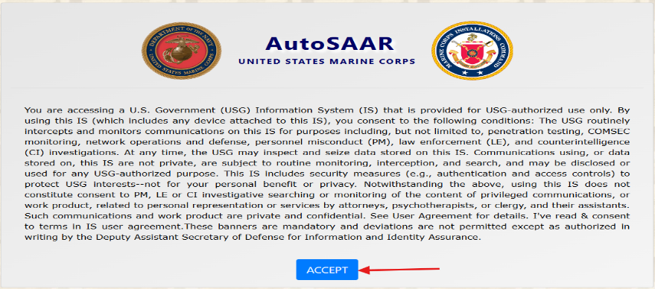
- Fill out all required information in this section and click Save. Zoom in on the image attached to this step for more details on how to complete each field.
Note: While completing the SAAR:
  - List SSgt Patrick Mullins (Patrick.Mullins@usmcu.edu) or
Carlton Spicer (Carlton.Spicer@usmcu.edu) as the Security Manager.
  - List your supervisor as the approver. (If you do not select your supervisor, the process will stall.)
  - Your supervisor must log in to AutoSAAR and approve your request.
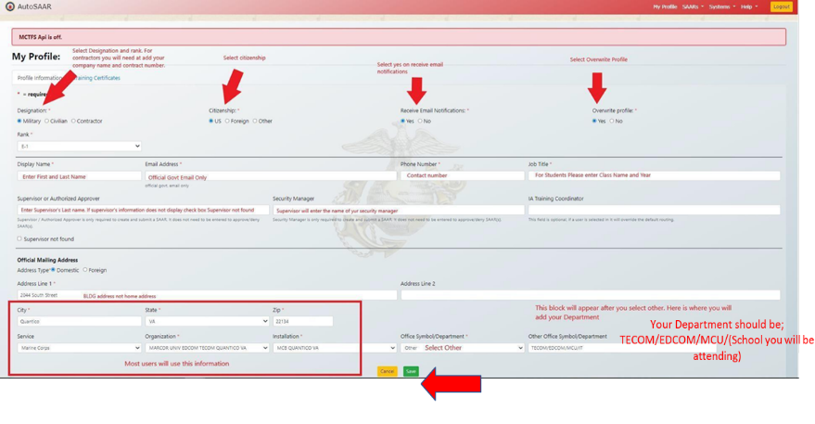
- Click Training Certificates in the top left, add your Cyber Awareness training certificate, then click Upload.
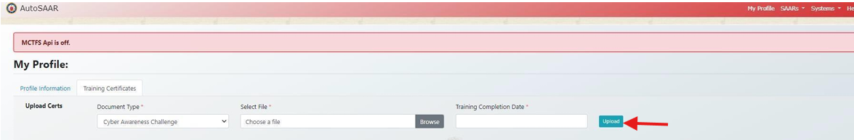

Step 3: Submit your EDU AutoSAAR
Log onto AutoSAAR portal using the following link below https://autosaar.usmc.mil/
- Click on accept
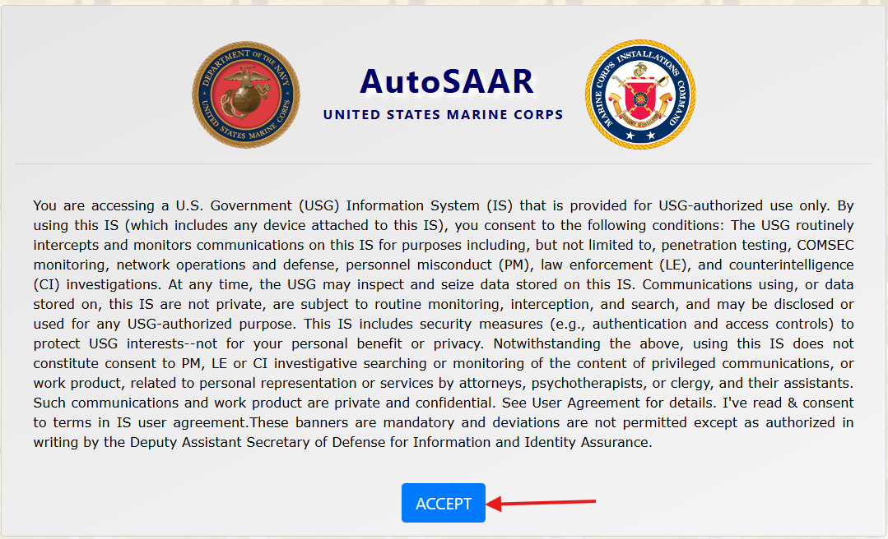
- Click on Create SAAR
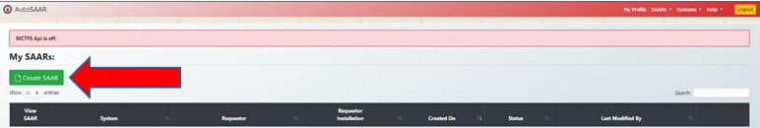
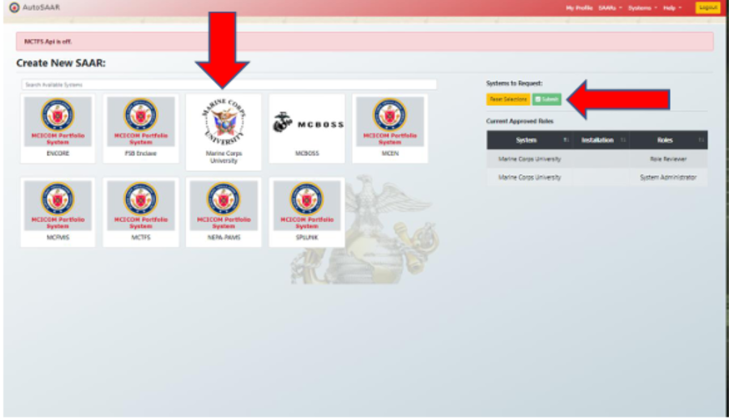
- Scroll through the organizations and find the Marine Corps University logo and select it, then scroll to the top of the page and hit submit to submit your selection.

  - Select your request type and role. Then enter your EDIPI number, located on the back of your CAC. Finally, provide your justification for access and click CONTINUE
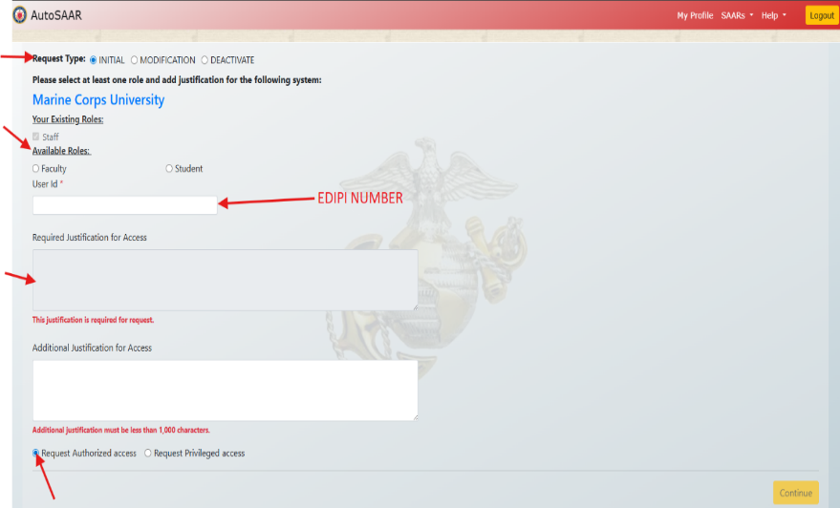
    - Click NEXT
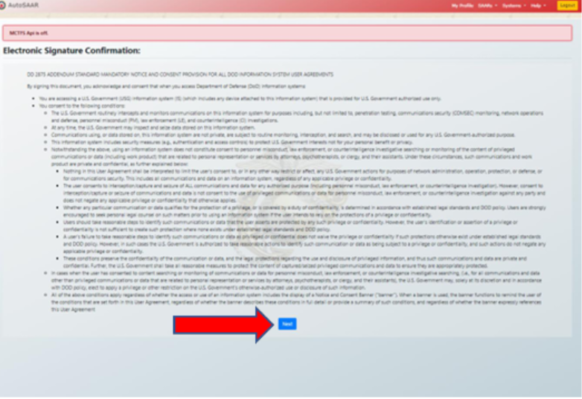

- Select the checkbox to confirm that you have read and agree to the terms and conditions, then click E-Sign.
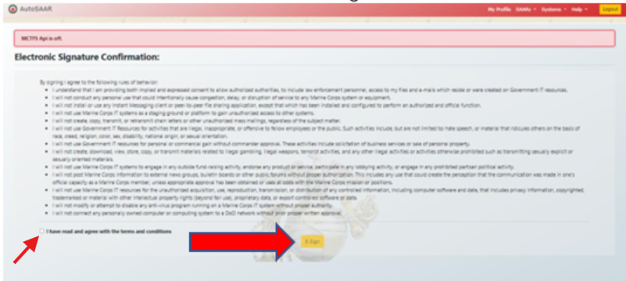
    - You will now be returned to the home screen, where you can track the Status of your requests.
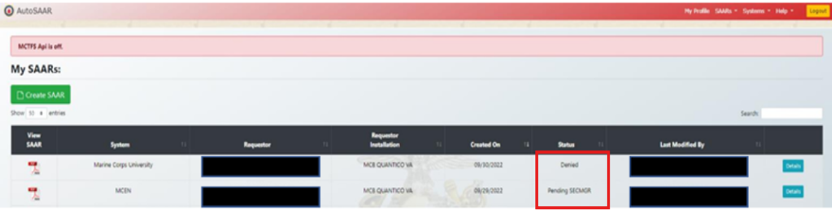
If you have issues at any point, contact the MCU IT helpdesk:
- Email: mcuhelpdesk@usmcu.edu
- Location: Warner Hall, Room 1124

