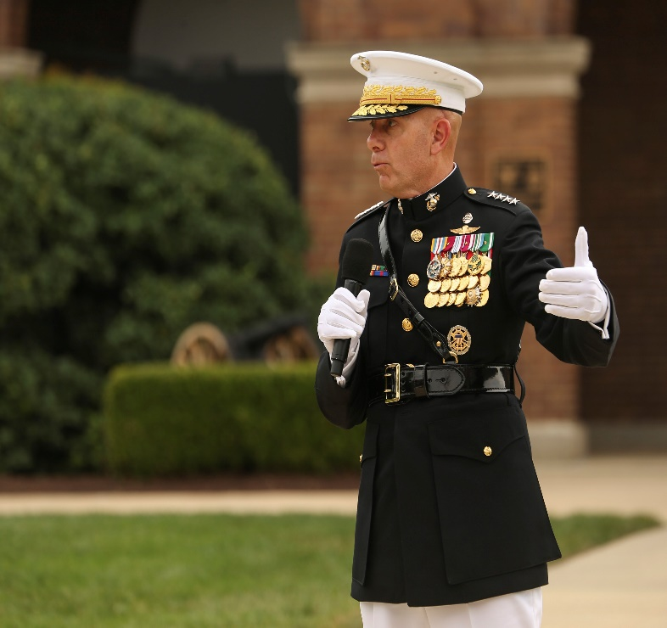
DRESS BLUE ”A” Smart Pack
Dress Blue “A” Smart-Pack
- Dress Blue White Combination Cover
- Silver and Gold EGA
- Gold and Red Chin Strap
- 2x Golden Eagle Screws to hold Chin Strap
- Gold and Silver EGA Collar Devices
- The anchors for the EGA’s should face inward
- Shoulder Insignia
- Should be centered and equidistant from both sides
- White Collar insert
- Appropriately sized to the wearer. Should have 1/4” – 1/2” of overlap (left over right)
- Sam Browne Belt
- Ensure fitting prior to event
- Buckle should overlap gig line
- Medals should be worn appropriately per the below diagrams
- Anodized medals
- Ribbons for all non-medals worn over right pocket 1/8” and centered
- Dress Blue Jacket
- Steamed and pressed
- White long sleeve shirt w/ cuff links
- White Gloves
- White Trousers
- Web Belt with gold buckle or suspenders(recommended while wearing Sam Browne belt)
- Appropriate under garments should be worn as to not to be seen under the trousers
- Steamed and pressed
- Corframs
- Clean free of scuffs and dirt
- Black socks
