First Sergeant Monica Cervantes
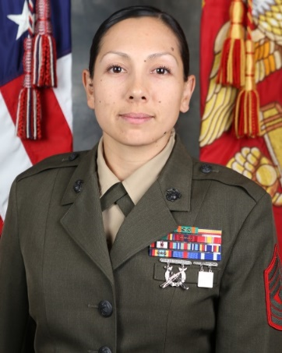
First Sergeant Cervantes enlisted in the Marine Corps on 28 June 1999 and went to Recruit Training at Marine Corps Recruit Depot, Paris Island, SC on 21 August 2000. Upon completion, she attended Marine Combat Training, Camp Lejeune, NC and attended Communications School in 29 Palms, CA. From March 2001-Dec 2001 First Sergeant Cervantes was assigned to III MEF, 7th Communications Battalion, Communications Company, Radio Platoon, Okinawa. She deployed in support of Operation Tandem Thrust, Rock Hampton, Australia and was promoted to the rank of Lance Corporal. While with III MEF, First Sergeant Cervantes was also attached to the 31st Marine Expeditionary Unit while in Okinawa Japan.

In January 2002, 1stSgt Cervantes received orders to 1_{st} Marine Division, Headquarters Battalion, Communications Company, Radio Platoon. She was then promoted to the rank of Corporal. In February of 2003, she deployed to Iraq for Operation Enduring Freedom. Where she was attached to serve as a liaison for the Army and Marine Corps. 1stSgt Cervantes returned back from Iraq in September of 2003. While there she served as the Platoon Sergeant for Radio platoon.

In February 2005, 1stSgt Cervantes was assigned to I Marine Expeditionary Unit, G-6. There she served as the Colonel’s aid and Terminal Area Security Officer. As the TASO 1stSgt Cervantes created and maintained all 3270 accounts for the MEF.

In November 2006, 1stSgt Cervantes received orders to Marine Corps Recruiting Station, San Diego CA. As a canvassing recruiter First Sergeant Cervantes was Recruiter of the Month and recruiter of the quarter.

In November 2009, 1stSgt Cervantes received orders to III MAW, Marine Wing Communications Squadron 38 (MWCS-38), where she served as the Alpha Company Radio Chief. During this period, the Detachment deployed in support of Operation Enduring Freedom 10.1. 1stSgt Cervantes served as the Transmissions Platoon SNCOIC, Uniformed Victim Advocate, EKMS manager and Safety manager.

In January of 2012, First Sergeant Cervantes reported to 3D MLG, CLR-37, Communications Company, Camp Kinser, Okinawa. While there she served as the Transmissions chief, company UVA, attended Advanced course, was selected to GySgt and selected for the Staff Degree Completion Program.

In December of 2012 GySgt Cervantes reported to 4th Tank Battalion, I&I Station as a student while on the Staff Degree Completion Program. While attached to 4th Tank Battalion, GySgt Cervantes served as the UVA and completed her Bachelors in Psychology.
Upon graduation GySgt Sergeant Cervantes reported to MCI-West, Base Safety Marine Corps Base Camp Pendleton for her pay back tour. At Safety, 1stSgt Cervantes became the Ground Safety for Marines lead instructor.

In May 2016, she received orders to 7th Engineer Support Battalion, 1st Marine Logistics Group, Camp Pendleton, as the Company First Sergeant for Bridge Company. In January 2018, First Sergeant Cervantes took over as the Bulk Fuel Company 1stSgt.

In September 2018 1stSgt Cervantes reported to Lejeune Leadership Institute to serve as the senior enlisted advisor.

First Sergeant Cervantes holds a Bachelor’s degree in Psychology and a Master’s degree in Performance Psychology from National University.

First Sergeant Cervantes’ personal decorations include the Navy Commendation Medal (second award), Navy and Marine Corps Achievement Medal (third award), and Good Conduct Medal with bronze star.

